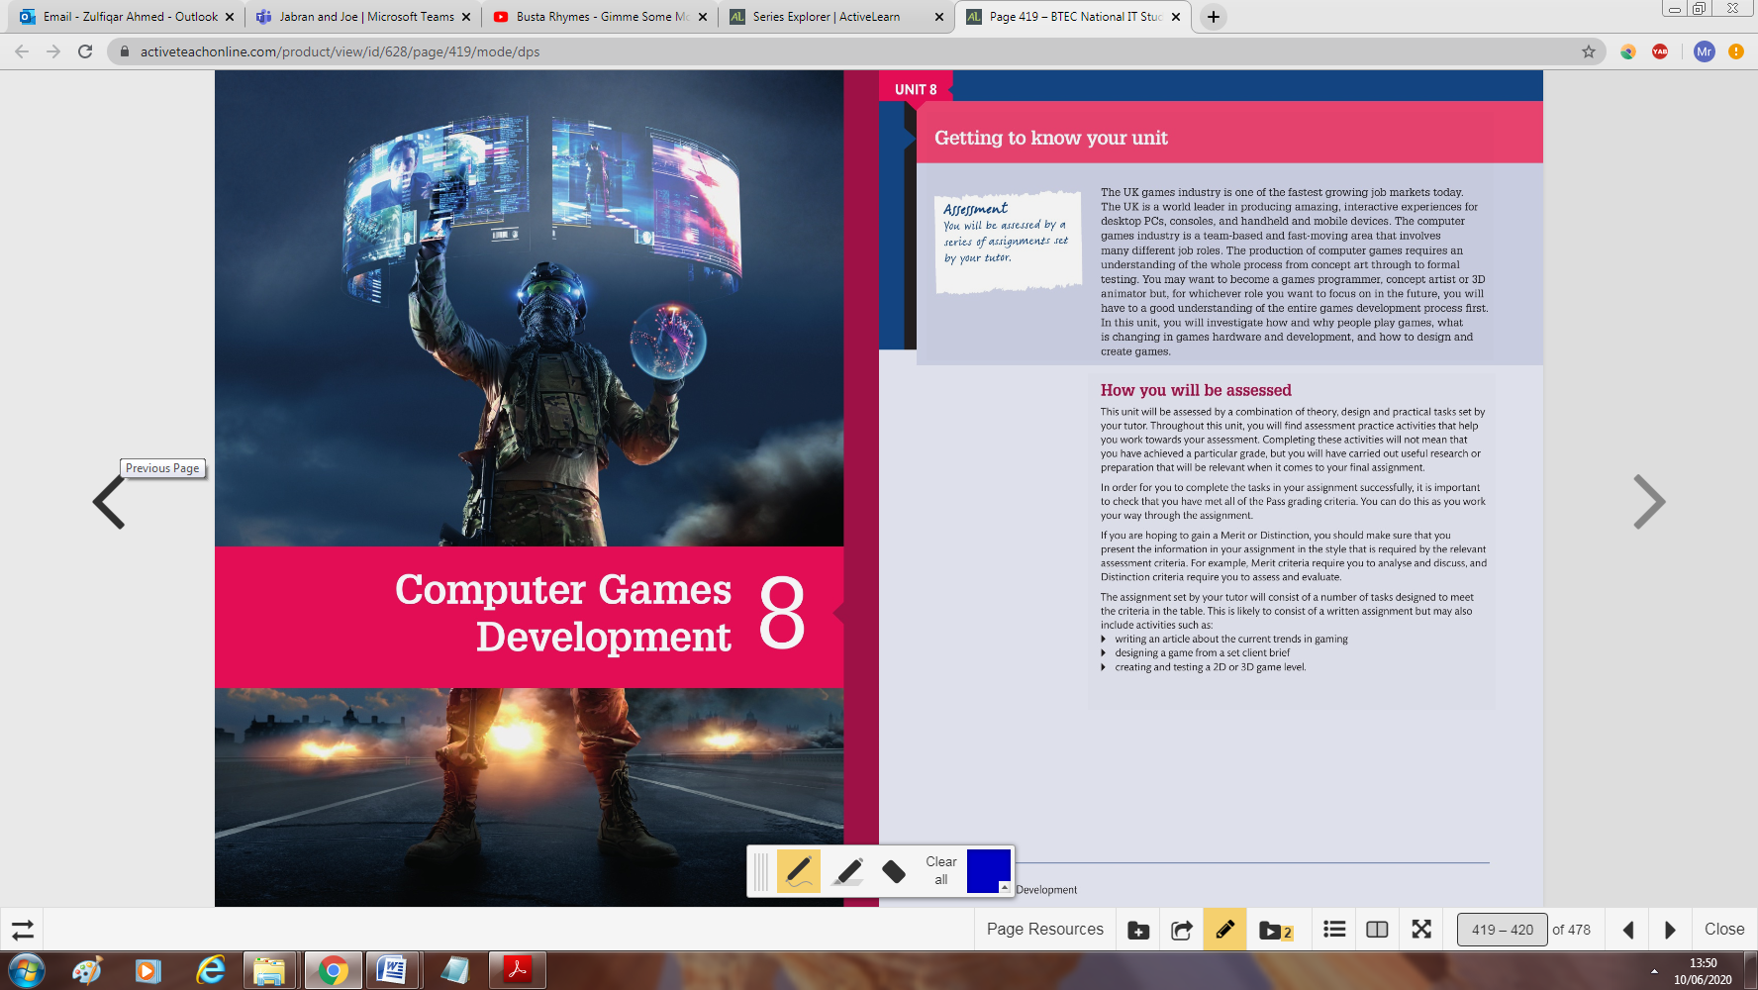

**Unit 8 Booklet 1**

<Enter your name here>

**Content to be covered**

A1 Social trends in computer gaming

Social trends relevant to computer games, including:

• popular genres

• players, e.g. age range, gender, casual gamers, immersive gamers, themes

• game production, e.g. mainstream publisher, indie, free-to-play

• multiplayer

• artificial intelligence, e.g. search algorithms, mathematical optimisation, logic

• emerging technologies **(vr, augmented reality, thought input, voice)**

• security of integrated services and multiplayer environments, e.g. Steam, Google Play

A2 Technologies used in computer gaming

• Benefits and limitations of different platform options for the development of computer games:

* personal computers, e.g. Windows, Mac
* consoles, e.g. PlayStation, XboxTM, Nintendo
* mobile devices, e.g. smartphones, tablets, notebooks
* web based, e.g. Flash, HTML5.

• Hardware options and their effect on the development of computer games, including:

* central processing unit (CPU)
* graphics processing unit (GPU)
* memory, e.g. random-access memory (RAM), read-only memory (ROM)
* output, e.g. display, sound
* input, e.g. keyboard/mouse, touch, gamepad, joystick, kinetic, voice
* storage, e.g. hard disk drive, cloud
* connections, e.g. internet, local area network, mobile network
* new technologies.

• Software options and their effect on the development of computer games, including:

* operating system, e.g. Windows, Mac OS, Linux
* programming language, e.g. C++, Java
* device drivers, e.g. input/output devices
* graphic options, e.g. DirectX, OpenGL
* audio options, e.g. music, ambiance, file format.

• Uses of game engines, their capabilities and how they aid computer game developers,

including:

* rendering engines
* physics engines
* collision detection
* scripting
* animation

**Assessment criteria**

|  |  |  |
| --- | --- | --- |
| **Learning aim A: Investigate technologies used in computer gaming** | | |
| **Pass** | **Merit** | **Distinction** |
| Explain social and technological trends of computer games. | Discuss how current and emerging technologies impact on how games are designed and developed to meet the requirements of the users and the larger computer games industry. | Evaluate the impact of current and emerging technologies on the design and development of computer games to meet the requirements of the users and the computer games industry. |
| Explain how current and emerging technologies impact on computer games design and development. |

**Learning aim A: Investigate technologies used in computer gaming**

**A1 Social trends in computer gaming**

1. Identify a popular computer game below:

_______________________________________________

1. Can you identify the type of genre of game identified from the previous question?
2. List and describe the types of computer game genres in the table below:

|  |  |
| --- | --- |
| Type of genre | Description of genre |
|  |  |
|  |  |
|  |  |
|  |  |
|  |  |
|  |  |

See p.422 of the student IT book for help.

Types of player

Computer games can be categorized into different genres, it is also important to consider different types of player.

1. Complete the table below:

Table: Main factors that determine the different types of computer game players.

|  |  |
| --- | --- |
| Factors | Description |
|  |  |
|  |  |
|  |  |
|  |  |

See p.423 of the student IT book for help.

Game production

See p.424 of the student IT book for help.

1. Explain the initial stage of game production before the concept art is created for any game.

Types of production

1. Complete the table below:

|  |  |
| --- | --- |
| **Type of production** | **Description** |
| Mainstream publisher |  |
| Indie games |  |
| Crowd funding |  |
| Freetoplay |  |

1. Explain the difference between indie games and crowd funding below:

Use of Artificial intelligence within production See p.425-426 of the student IT book for help.

1. Complete the following section below:

|  |
| --- |
| **Artificial Intelligence:** |
| Explain how AI can be used within the production of a game. |
|  |
| Why do you think it is necessary to use AI within any computer game? |
|  |
| **Search Algorithms:** |
| Explain the A* algorithm? |
|  |
| Why would this algorithm be useful within the context of developing a computer game? |
|  |
| Can you give two different scenario’s of this algorithm being used within a computer game? |
|  |
| **Mathematical optimization:** |
| What is the purpose of mathematical optimization? |
|  |
| Explain the consequence of not using this method? |
|  |
| **Logic:** |
| What is the term logic referred to within the production of a game? |
|  |
| If the game does not follow the logic and patterns of human behaviour, why would this be of a concern to a developer? |
|  |

**Emerging technologies**

1. Complete the following section on emerging technologies. See p.426-427 of the student IT book for help.

|  |
| --- |
| **Virtual reality** |
| Explain VR below, its use, benefits and limitations of emerging technology |
|  |

|  |
| --- |
| **Augmented reality and wearable technology** |
| Explain AR below, its use, benefits and limitations of emerging technology |
|  |

|  |
| --- |
| **Digital distribution** |
| Explain digital distribution below, its use, benefits and limitations. |
|  |

|  |
| --- |
| **Streaming** |
| Explain streaming below, its use, benefits and limitations. |
|  |

Security of integrated services and multiplayer environments See p.427 of the student IT book for help.

1. Explain the need of security in gaming systems in comparison to 20 years ago.
2. How can players be exploited by revealing personal information? Give example

**A2 Technologies used in computer gaming**

1. This task will look at identifying the different hardware and their effect on the development of computer games. See p. 427-428 of the student IT book for help.

|  |
| --- |
| **Central processing unit (CPU) -** Give explanation of hardware along with its impact on PC and game consoles. (please include examples to support your explanation) |
|  |
| **Graphics processing unit (GPU)** - Give explanation of hardware along with its impact on PC and game consoles. (please include examples to support your explanation) |
|  |
| **Memory**, e.g. random-access memory (RAM), read-only memory (ROM) and **storage**, e.g. hard disk drive, cloud. –Explain hardware and impact on PC and game consoles. (please include examples to support your explanation) |
|  |
| **Input**, e.g. keyboard/mouse, touch, gamepad, joystick, kinetic, voice. Explain the different inputs and how they are used within PC and consoles along with trends in different inputs becoming popular.(e.g. use of touch on portable devices) |
|  |
| **Output**, e.g. display, sound. Explain the different outputs and how they are used within PC and consoles. |
|  |
| **Connections**, e.g. internet, local area network, mobile network. Explain the different methods of connection and how they are used within PC and consoles. |
|  |

|  |  |  |  |
| --- | --- | --- | --- |
| **Platform** | **Type** | **Benefits** | **Limitations** |
| Windows PC |  |  |  |
| Mac |  |  |  |
| PS4 and Xbox one |  |  |  |
| Nintendo Wii U |  |  |  |
| Apple IOS devices |  |  |  |
| Android devices |  |  |  |
| Adobe Flash |  |  |  |
| HTML 5 |  |  |  |

**Benefits and limitations of different platform options for the development of computer games.**

1. Complete the table See p.428 of the student IT book for help.

**Software options and their effect on the development of computer games**

1. Complete the following tasks below:

|  |  |  |
| --- | --- | --- |
| **Operating System-**Explain the impact of an OS for the following below: | | |
| **PC (impact of OS)** see p.430 of student IT book for help | | **Console (OS)** see p.430 of student IT book for help |
|  | |  |
| **Programming languages and graphic options, e.g. DirectX, OpenGL-** Explain how this would impact on the development of a game below: (see p.430 of student IT book for help) | | |
|  | | |
| **Device drivers**, e.g. input/output devices -explain the purpose and its use within the context of a computer games  see p.430 of student IT book for help | **Audio options**, e.g. music, ambiance, file format. – Explain the purpose and use of audio/sound within the computer games.  see p.430 of student IT book for help | |
|  |  | |

**Uses of game engines, their capabilities and how they aid computer game developers**

See p.431-432 of the Student IT book for support.

1. Explain what is a game engine?
2. Explain the benefits of a game engine to a developer?
3. Give two examples of game engines and how it’s been used within the gaming industry?
4. Complete the diagram below by identifying what tasks a game engine can be responsible for:
5. Complete the table below about game engine roles:

|  |  |
| --- | --- |
| **Game engine roles** | **Explanation** |
| Rendering |  |
| Physics |  |
| Collision detection |  |
| Scripting |  |
| Animation |  |



